Kevin Krantz, CPA
Instructor
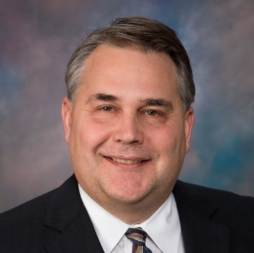
Kevin has spent more than 30 years in public accounting, assisting closely held business owners with their accounting and tax needs. After graduating from the University of Akron with a master’s degree in taxation, his career path took him to both local and regional accounting firms. Kevin instructed at tax conferences around the country before joining 20-20 Services LLC in 2015. He currently practices at Krantz & Company, CPA, LLC.
Kevin acts as an instructor for 20-20 Services. He leads public and in-house training programs for both Tax and Audit services.
Kevin lives in the Cleveland area with his wife and four children. He can be found camping, golfing, or following Cleveland’s sports teams.

